**Performance Test Report**

**For**

**Execution of**

**Kernel UIN Generator– 350 users**

Date: 06 June 2020

Author: Gaurav Sharan

**Summary**

This report presents the observations and findings of the load test conducted for a load of 350 users on kernel UIN generator services.

The objective of this load test was to observe and record behavior of the uin generator service when user load is increased from 200 to 350.

Below are the scenario details:

|  |  |
| --- | --- |
| **Script/Report Name** | Kernel UIN Generator Service |
| **Run Date** | 06-June-2020 |
| **Period** | 10:22:37 UTC to 11:03:07 UTC |
| **Number of concurrent users** | 200 to 350 |
| **Ramp up** | 01 user per second |
| **Run Duration** | --- |
| **Ramp down** | NA |

The transaction response times observed were as below:

|  |  |  |  |  |  |  |  |
| --- | --- | --- | --- | --- | --- | --- | --- |
| **Label** | **# Samples** | **Average(ms)** | **90% Line(ms)** | **Min(ms)** | **Max(ms)** | **Error %** | **Throughput** |
| TR_idrepo_generate_uin | 225527 | 1152 | 1503 | 16 | 24985 | 0.35% | 92.8/sec |

**Performance Test Execution Details**

We have executed JMeter script for kernel UIN generator service, which has transactions mentioned in the above table.

Average response time of the APIs is 1152 ms with error rate 0.35 %

**Response Time and TPS Graph:**

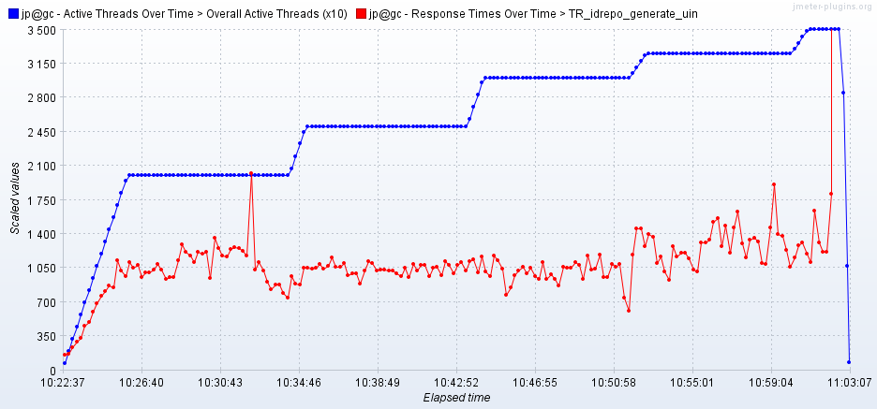

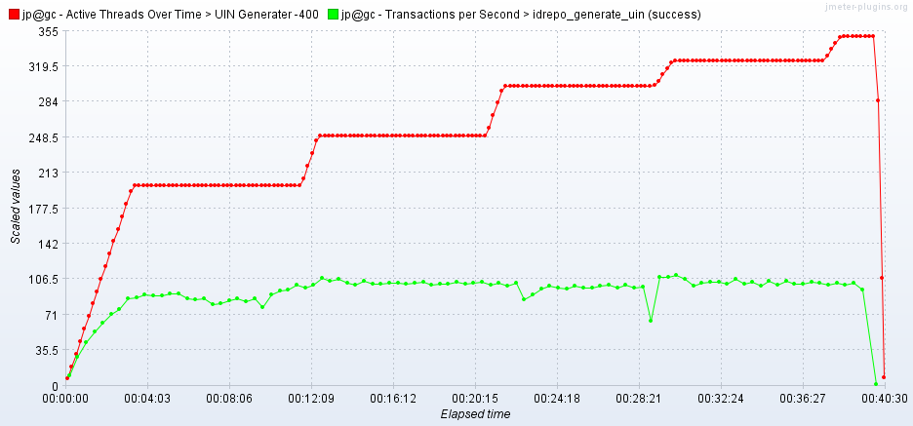

As seen in the response time graph, response time of the APIs is approx 1.4 sec when 325 users are active

Throughput (TPS) of the APIs reaches 103 when 200 users are active and stays at same level even when number of active users becomes 325.